Position Statement

NSW Government urged to build framework to support disability advocacy

The Disability Council NSW urges the NSW Government to build a regulatory and funding framework that will provide disability advocacy organisations and their service provision with a sustainable future. There are real fears in the community that government support for disability advocacy organisations and services will be substantially less than it had been in the past and that people with disability will suffer because of this, given the crucial role that advocacy plays in securing their welfare. The Disability Council strongly advises the government to take action to allay these fears by establishing a system that provides certainty and security to the future disability advocacy in NSW.

Essential function of advocacy for people with disability

The Disability Council stresses that disability advocacy performs an essential function in ensuring that the rights and interests of people with disability, both at an individual and systemic level, are respected and upheld by all sectors within the community. Disability advocacy can in no way be considered an optional extra in the support that is provided to people with disability.

The rights of people with disability as full and valued members of the community and their needs as individuals and as a group have all too often been ignored in the past and placed in the “too hard basket”. Disability advocacy has helped to redress this imbalance by allowing people with disability, their carers and their families to access the services of skilled professionals who can act on their behalf to see that they are afforded with their respect due as full members of the community.

The importance of the support provided by disability advocacy professionals and organisations is even clearer in the cases of people with disability who face additional barriers to having their rights respected and accessing the services that they need. These include people with disability from rural and regional areas, Culturally and Linguistically Diverse (CALD) backgrounds and those who are Aboriginal or Torres Strait Islander. The NSW Government must act to provide certainty regarding the continued funding of disability advocacy services to ensure that all people with disability, including those who face additional disadvantage, can receive the support that they need.

Inadequate NDIS support for advocacy

Much of the concern around the long-term security of the funding arrangements for disability advocacy services stems from the fact that there is little scope for funding disability advocacy within the National Disability Insurance Scheme (NDIS) and its allied programs (including Information, Linkages & Capacity building (ILC) grants). This is despite the fact that funds that NSW has directed to the NDIS, previously went towards disability advocacy services when the NSW Government was responsible for the delivery of disability services.

Consequently, the Disability Council believes that it is unreasonable for the NSW Government to expect that the funding of disability advocacy services can be accommodated under the NDIS in its current form. Therefore, action needs to be taken by the NSW Government to devise a new framework (which may involve collaboration with the Commonwealth Government) that can provide certainty on the regulation and funding of disability advocacy services into the future.

People with disability who are not NDIS participants

The Disability Council is especially concerned that the need for advocacy services by people with disability who are not NDIS participants has not been adequately provided for by either the NSW or Commonwealth Governments. The advent of the NDIS has meant that NSW Government funds that were previously employed to assist a broader spectrum of people with disability in NSW now only benefits people with disability who are NDIS participants. The Disability Council calls on the NSW Government to take action to ensure that people with disability in NSW who are not NDIS participants are not left to fall through the cracks in terms of accessing the disability advocacy services that they need.

Recommendations for reform

The Disability Council NSW endorses recommendations made by the NSW Ageing and Disability Commissioner, Mr. Robert Fitzgerald AM, in his report, Review into Disability Advocacy in NSW, published on 19th December 2019. At the core of the Commissioner’s recommendations, was that the NSW Government needs to create a permanent and sustainable framework for disability advocacy provision coordinated by a new independent body, the NSW Disability Advocacy Futures Program (DAFP). The DAFP that would fund and regulate the provision of advocacy services for all people with disability into the future. The proposed DAFP would fund and regulate:

- systemic disability advocacy;
- individual disability advocacy; and
- allied special purposes and projects.

The DAFP would also fund the establishment of the proposed:

- Centre for Disability Advocacy Development (NSW) which would improve the development of high quality, sustainable disability advocacy services and provide community information about access to disability advocacy; and
- NSW Disability Advocacy Network (DAN), a membership based advocacy network of providers who receive funding from the DAFP to drive improvement, collaboration and innovation among advocacy organisations.

The Disability Council NSW also recommends that the NSW Government ensure that any guiding committee for the DAFP includes members that have lived experience of disability, including a representative taken from the Disability Council NSW. The Disability Council NSW also endorses the other recommendations made by the Commissioner in support of this core recommendation to establish and fund the DAFP. The additional recommendations were that:

- the NSW Government establish transparent funding principles within the DAFP for disability advocacy organisations, made in consultation with the sector and people with disability. With respect to the principles for funding the advocacy organisations, the Disability Council NSW recommends that within the DAFP framework, the NSW Government make stipulations that cover people with disability who are consulted on an ongoing basis be remunerated.
- the NSW Government develop a clear and consistent system for assessing the quality of services and performance of disability advocacy providers.
- the NSW Government work with the Commonwealth Government and other state and territory governments to ensure that the next National Disability Agreement (NDA) sets out clearly which levels of government are responsible for the funding and regulation of disability advocacy services.
- principles should be established to compensate disability advocacy organisations for the advice and consultation services that they provide NSW Government departments and agencies in relation to their laws, policies and programs.
- more work needs to be done by all governments to ensure that all sectors of government and the community are aware of and value the services that disability organisations and professionals provide.
- the DAFP framework established by the NSW Government needs to be such that it allows for disability organisations to support capacity building and the development of staff.

In addition to these points, and in line with the comments made earlier in this letter, the Disability Council NSW recommends that the DAFP led framework developed by the NSW Government to secure and support the provision of disability advocacy services in the future needs to ensure that the it caters for the following sub-groups of people with disability:

- people with disability who are not NDIS participants.
- people with disability living regional and remote areas of NSW.
- people with disability from CALD backgrounds.
- people with disability who are Aboriginal or Torres Strait Islander.

Working to create a permanent and properly funded NAFP to support the disability advocacy organisations and the delivery of advocacy services will bring much needed certainty to the sector and to the people with disability that they serve. The end of uncertainty and additional resources that the NAFP will bring will also allow the disability advocacy sector to begin to look forward again by building capacity and developing the skills of their staff to better serve the needs of people with disability in NSW.

Conclusion

The Disability Council NSW would also like to offer the NSW Government any assistance it can in developing a framework and systems that will support disability advocacy organisations and the delivery of advocacy services to people with disability in NSW. The Council is also able to consult with disability advocacy organisations to assist the NSW Government obtain additional community input to assist the development of any future systems and framework.

Mark Tonga
Chair
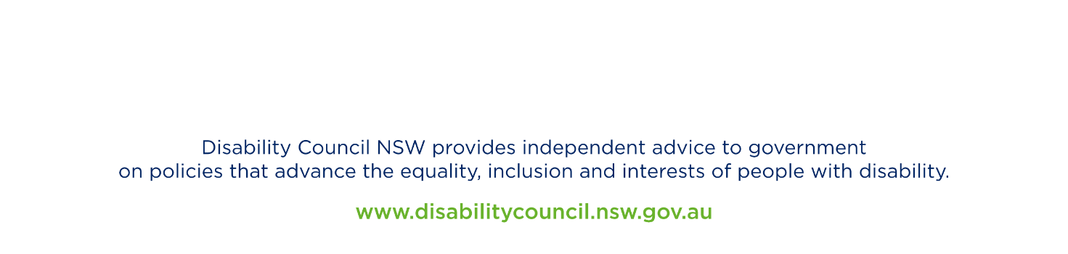
Disability Council NSW

2 July 2020

