Communiqué

26 June 2020

Due to the ongoing COVID-19 (Coronavirus) pandemic, the third meeting of the Disability Council NSW (the Council) for 2020 was held virtually.

At the meeting, the Council endorsed its position paper on the NSW Ageing and Disability Commissioner’s review into the provision and funding of disability advocacy in NSW. The position paper will be made available shortly on the Council’s website.

The Council meeting was attended by the Hon. Gareth Ward MP, Minister for Families, Communities and Disability Services. Minister Ward spoke on the extensive COVID-19 pandemic response measures undertaken by the Department of Communities and Justice (DCJ) and the National Disability Insurance Agency (NDIA) to keep vulnerable people connected to their communities and the services they need.

With the second anniversary of the National Disability Insurance Scheme (NDIS) and the first anniversary of the establishment of the NSW Ageing & Disability Commission (ADC) approaching, Minister Ward expressed his gratitude and acknowledged that the NSW Government is leading the way in key aspects of disability policy in the country.

When asked about the future of disability advocacy in NSW, Minister Ward advised members of the extension of existing advocacy funding until the end of the year. Future funding arrangements will be determined following the NSW budget later this year.

The Council welcomed the Commissioner of the NSW Ageing & Disability Commission (ADC), Mr Robert Fitzgerald AM, to its meeting. Mr Fitzgerald reported that nearly a year has passed since the ADC’s establishment and that it is fulfilling all of its functions. The Commissioner discussed data trends concerning the number and type of abuse inquiries/reports the ADC had received. He expressed his commitment towards improving data transparency and the ADC’s plan to publish a monthly data dashboard. The Council backed the Commissioner’s efforts to build a strong framework of data and evidence collection.

The Commissioner reported on the establishment of the Ageing and Disability Advisory Board, which will advise him on issues related to abuse, neglect and exploitation of vulnerable older people and adults with disability. The Commissioner also raised that the ADC will seek the Council’s views and advice on a number of important topics including the NSW Government’s implementation of the National Disability Strategy (NDS).

Mr Brian Woods and Mr Richard Hawkins from the DCJ’s Disability Policy team, joined the Council to identify the best approach for the Council to advise the Minister on issues that are considered by the Disability Reform Council (DRC).

The Council identified three forums that it will hold with the disability community in the second half of 2020. The Chair emphasised that the main goal of these forums is to directly engage with the disability sector, to present the Council’s focus areas for 2020 and to learn more about the issues that causing concern in the broader community. These forums will demonstrate the Council’s commitment to engaging deeply with the disability community and to acting as their chief advocates within the NSW Government.

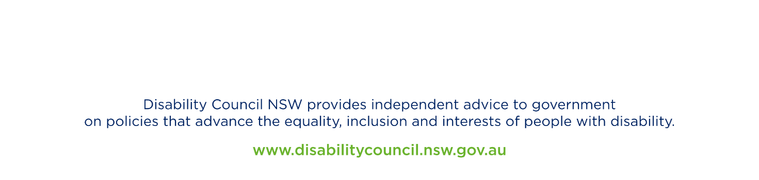
The Council will next meet on 21 August 2020.

Mark Tonga
Chair
Disability Council NSW

