Communiqué
28 October 2020
The Disability Council NSW held its second virtual forum on Wednesday 28 October 2020.
Mark Tonga, Disability Council Chair, opened the two-hour forum discussing issues impacting the disability sector. With AUSLAN interpreters from Sweeney Interpreting and live captioning by AI-Media.
Council member, Mr Jake Fing opened the forum with an Acknowledgment to all Aboriginal and Torres Strait Islander countries across Australia with participants calling in from various locations. The Council Chair, Mr Mark Tonga, provided an overview of the forum and introduced the 11 Council members.
Mr Mark Tonga briefed the participants on the role of the Council and how it supports the NSW Government by providing independent advice related to people with disability to the Minister for Disability Services, and highlighting the importance of hearing from people with lived experience.
Mr Mark Tonga also provided an overview of the four strategic priorities of the Council for 2020/21:
- Driving improvement in employment
- Influencing the National Agenda
- Progressing a successful National Disability Insurance Scheme (NDIS)
- Providing Advice
The forum allowed for participants to break into concurrent sessions, which were all facilitated by Disability Council members:
Sessions 1.
- Driving improvement in employment facilitated by Ms Donna Purcell
- National Disability Strategy, Improvements in digital technology: affordability, appropriate of design & technology & ability facilitated by Dr Jill Duncan
- Easy read (additional support) employment session facilitated by Ms Carolyn Campbell-McLean & Mr Paul Zeller

Session 2.
- Progressing a successful National Disability Insurance Scheme facilitated by Dr Rachael Sowen and Mr Jake Fing
- Advice: emergency situations, transport, housing, COVID 19 facilitated by Ms Casey Gray and Ms Prue Watt
- Easy read (additional support) Advice: emergency situations, transport, housing COVID 19 facilitated by Ms Carolyn Campbell-McLean & Mr Paul Zeller

Influencing the National Agenda
Funding allocated across the needs for people with disability.
Accessibility in rural, regional and remote areas – the market is often thin in these areas. Need to look at ways to encourage skilled people to move and work in areas. Unfortunately, people who move find less access to training and development to increase skills or progress their career.
It was felt that standards for universal design in online learning should be applied to all learning opportunities to ensure inclusion. Some local government did better than others at engaging and including people with disability in their decision making process. It was important all local governments do this.
It was noted people with disability aged over 65 do not qualify for the NDIS which the forum noted was an issue and how can we ensure they have access to services to safeguard their quality of life similar to those accessing NDIS services.
Even though improvements had been made in accommodation for young people with disability the forum noted there are still young people living in nursing homes and the need to continue to work towards a solution.
It is important that people with disability are involved in research both on the team as well as participants as this leads to a better piece of research.
Driving improvement in employment:
People with disability should be represented across all roles and levels in organisations including senior and leadership roles.
There are still barriers to obtaining employment, including accessing services, navigating recruitment processes including forms and lack of interview flexibility, lack of awareness of employers and leadership around disability and programs that could assist as well as underutilisation of Job Access.
Accessible transport to travel to and from work is still an issue. Appropriate workplace induction, on the job training, employee networks and disability awareness training for staff at all levels is required and understanding of resources available. Some felt employment programs were not very disability friendly.
Paying real appropriate wages even if subsidised.
An acknowledgement that some people with disability require supported employment, where their rights are protected with fair pay not discriminated.
The flexibility that COVID has provided for the opportunity to work from home using varied technology has been positive, however they didn’t want to see a situation where people with disability worked from home because it was easier as this is not what inclusion looks like.
They felt that the public sector could show more leadership in employing people with disability.
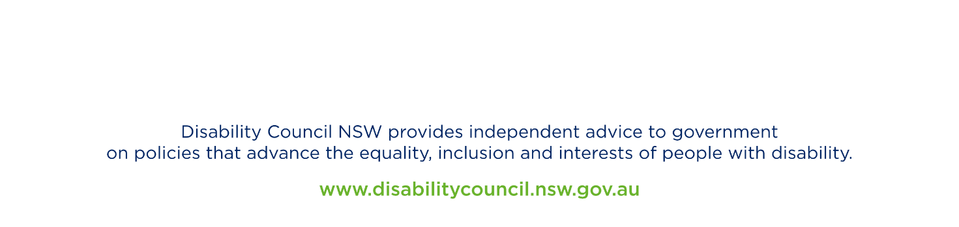
Providing Advice:
Emergencies and COVID more training for emergency and other services around support needs of people with disability is required. More targeted advertising about how people with disability can access information about COVID and how to prepare for emergencies.
The Royal Fire Service ran a program to support people with disability or who are elderly in high risk areas to help them prepare for the bushfire system which could be expanded to other emergencies.
There are websites and telephone hotlines targeting people with disability, however, more awareness on these are required. People with disability found lock down hard with people feeling more isolated. Social distancing can also be an issue for some people with disability.
Transport issues with lack of audio description for buses and people with disability being ignored by taxi drivers at taxi ranks. In regional NSW there were long waiting times and limited bus services. Training required for taxi drivers. It was suggested that buses adopt a similar audio description system to what railway transport provides.
Accommodation: rents were too high especially in Sydney, there was a need for both emergency and long term, decent and accessible housing. Universal design principles should be used for all properties.

Progressing a successful National Disability Insurance Scheme (NDIS):
Difficulty accessing funding for equipment and aids through the NDIS quickly. The different skill level of Local Area Coordinators (LAC). It was suggested that some LACs could specialise in particular needs and disabilities.
It was noted that it was a business first model based on finance and insurance and not necessarily for disabilities.
NDIS to bring the appropriate groups together; builders, NDIS, those seeking suitable housing to ensure accommodation is appropriate for the individual.

The Chair closed the forum by thanking the participants for sharing their valuable insights and ideas. The Chair stated that the Council would use information collected to fulfil its advisory function and when responding to important issues impacting people with disability, as well as advising the Government on appropriate program and policy decisions.

Mark Tonga
Chair
Disability Council NSW

#DisabilityCouncilForums

