# Printing at 180 Thomas Street – Register, Release Print and Scan

This user guide will help you register your new access card to the Lexmark Printer, release a print job and scan to your email.

1. How to install the printer queue on your device
2. How to register your access card to use secure print
3. How to release a print job
4. How to scan to your email

## Installing the printer queue on your device

To install the secure print queue on your laptop please click on the link below:

\\Central-print02\Secure Print at DOCJ

Once the link is opened a window will appear showing the process of installing the print queue automatically.

Once the printer is installed, go to **Printers & Scanners**:

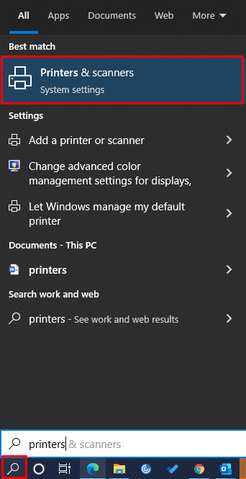

The printer will appear here:

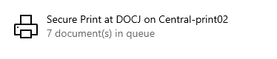

The queue will appear as shown below when you are in a document ready to print:

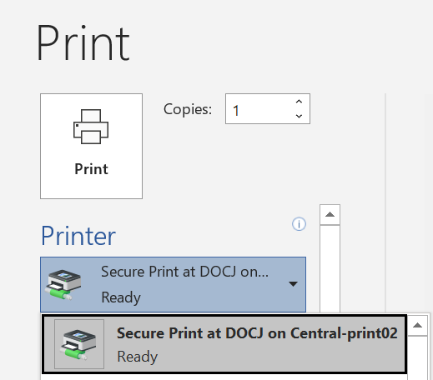

## Registering your access card to use secure print

To make printing quick and easy, your building access card should be associated with your login ID.

**Step 1** Go to a printerand it will display the Welcome screen shown below

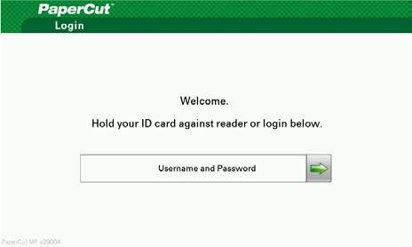

**Step 2** Hold your access card against the card reader (located on the right of the printer) then select **Next.**

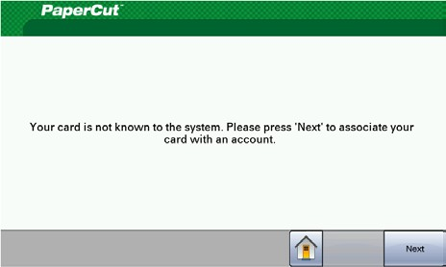

**Step 3** Enter your network login ID (the one you use to log onto your laptop) and then select **Next.**

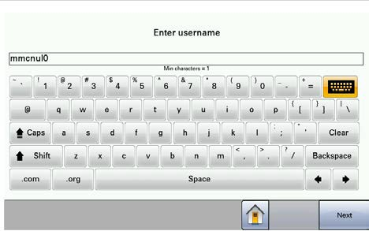

**Step 4** Enter your password (the one that you use to log onto your laptop) then select **Next.**

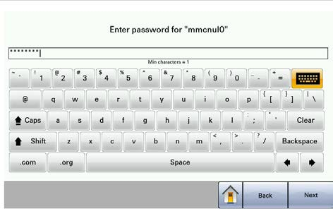

**Step 5** Your card is now associated with your network login ID and can be used to quickly access your print jobs.

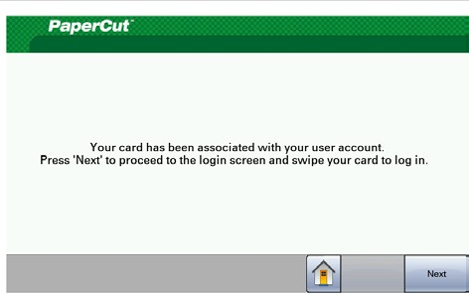

**Note:** If you enter your account details incorrectly you go back to step 1 and tap your access card again to register your Login ID.

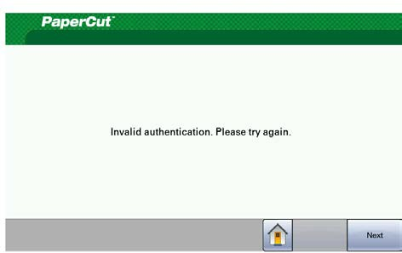

**Note:**  If you forget your card, you can log into the printer with your PC Login credentials.

## Releasing a secure print job

After sending a print job to the secure print queue from your laptop you can release it at *any printer.*

1.Go to a printerand it will display the Welcome screen shown below



2. Hold your card against the reader and select **Print Release** to see your jobs

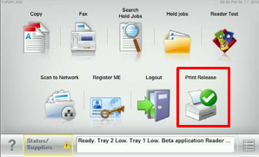

# To release a single job or multiple jobs

3.Press on the arrow next to the job you wish to print. Otherwise you can press **Print all** to release all your print jobs.

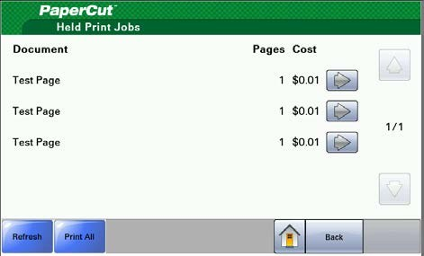

**4.** Press **Print** if you have selected a single job.

5.If a busy message appears select **Next**

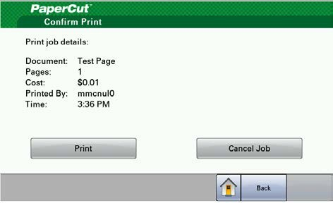

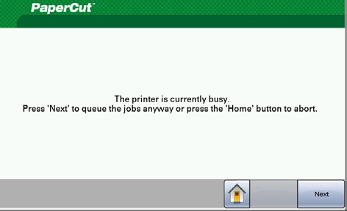

6.Select **Logout**

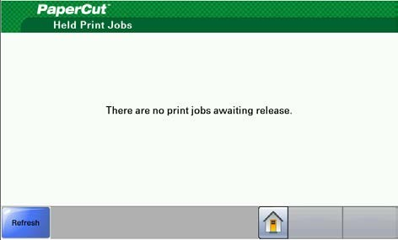

The display will automatically logout after 30 seconds.

Note: Secure Print jobs not released will be deleted after 24 hours in the secure print queue.

## Scanning to your email

1. Go to a printerand it will display the Welcome screen shown below



2.Hold your card against the reader and click the **Email** icon.

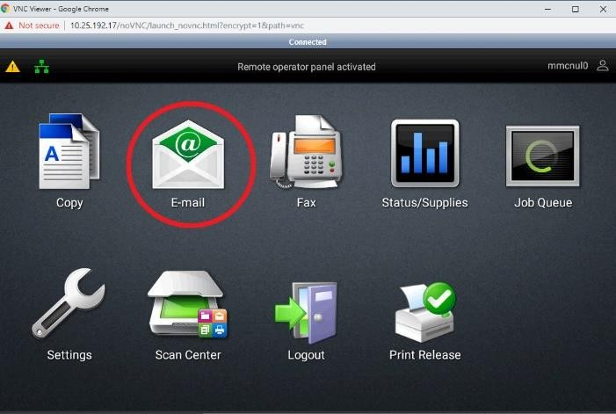

3.You can edit the **Subject**, **Message** and **Filename**. Your email will automatically populated. Click **Send** when ready.

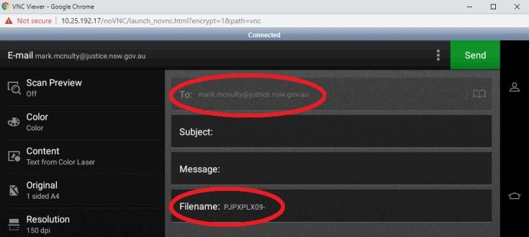

4. You will receive an email in your Outlook with the file as an attachment