Book and join a Teams enabled meeting room
This user guide will help you to book a Microsoft Teams (Teams) enabled meeting room and join the meeting so you can utilise the full functionality of the Teams room. It will show you how to:
- book a Teams enabled meeting room via Outlook
- book a Teams enabled meeting room via Microsoft Teams on your PC
- forward a Microsoft Teams meeting invite to a meeting room before the meeting begins
- join the Teams meeting.
Note: To join an existing or start a new Teams meeting from within the room, refer to the Join or start a Teams meeting from within the meeting room user guide.

1. Book a Teams enabled meeting room via Outlook
1 | Invite the meeting room to your meeting invite. Within the Outlook invitation, select the Location button and then start typing the suburb, building code and level to refine the room list in the Select rooms window. You can invite multiple rooms from the same invitation as required.  Note the format of Suburb code + Hyphen + Building code + Hyphen + “L” + Level number for example, PAR-6PSQ-L04, will show you all meeting rooms on level 4 at 6 Parramatta square in Parramatta:  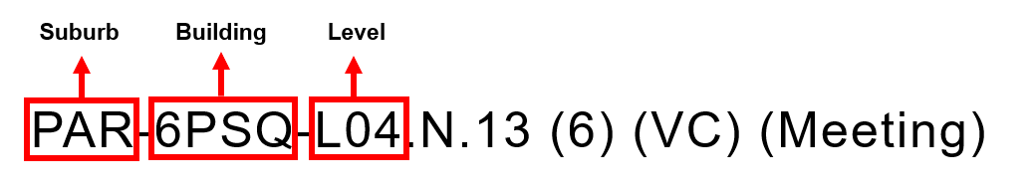  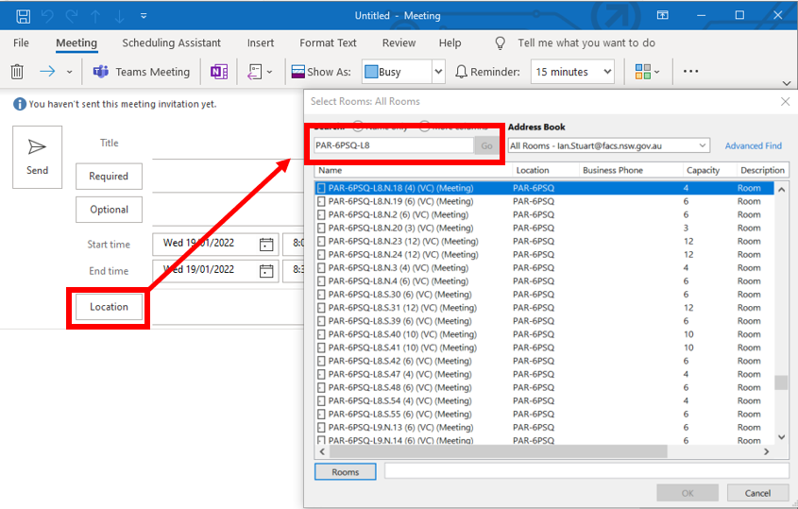
2 | Add a Teams link by selecting Teams Meeting.  If you do not see the Teams Meeting icon, you will need to refer to ‘Book a Teams enabled meeting room via the Microsoft Teams app installed on your PC’.  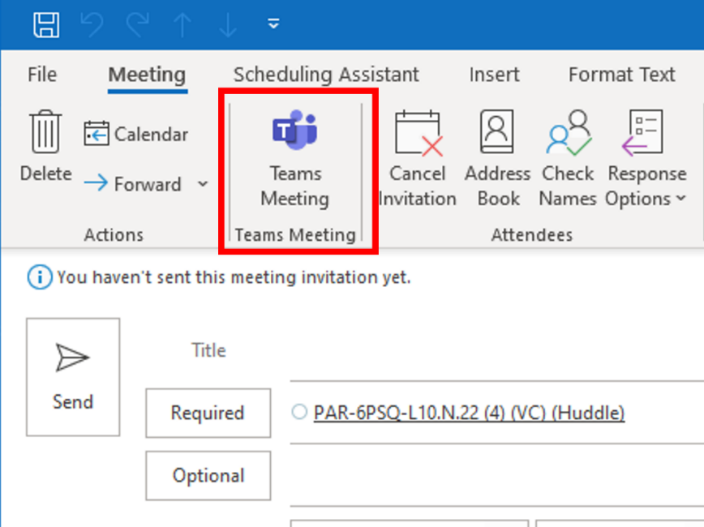
3 | The Microsoft Teams link has been added.  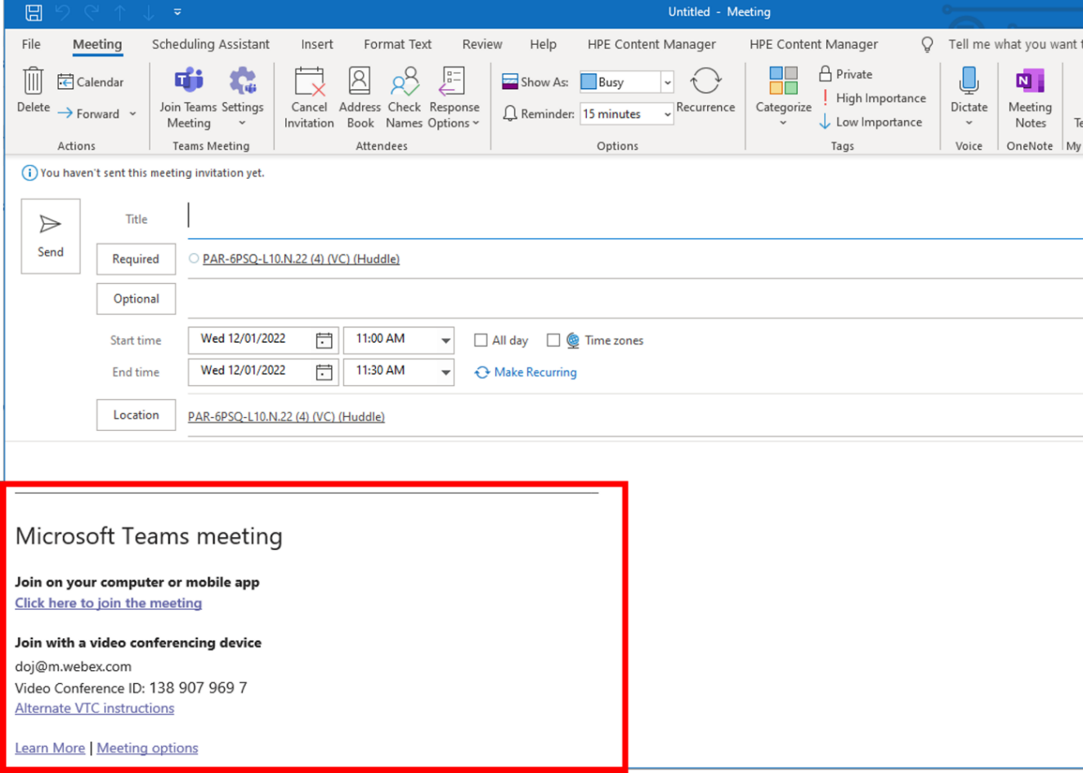
4 | Once you have sent the invitation you will receive an email notification confirming the room has been booked.  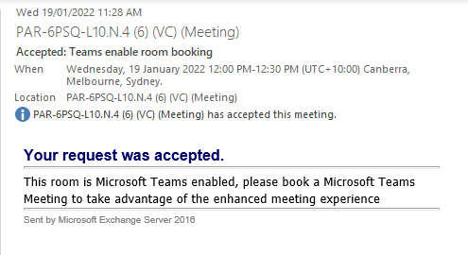  Note: you can forward a meeting request with a Microsoft Teams link to multiple rooms.

2. Book a Teams enabled meeting room via Microsoft Teams on your PC
1 | To start a new meeting in Teams, select the Calendar icon from the left hand menu and then select the New Meeting button.  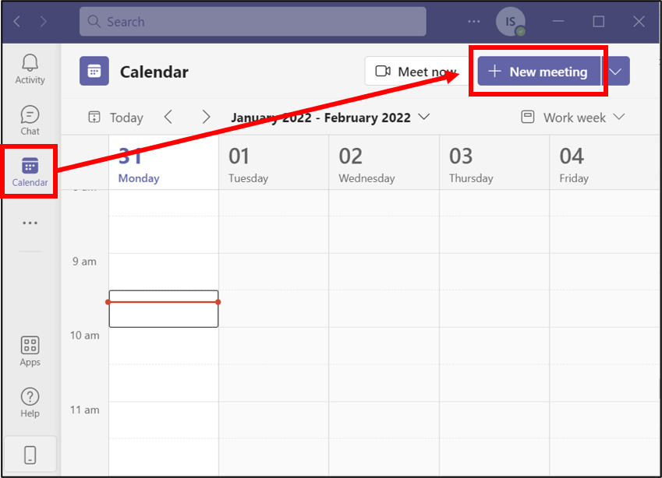
2 | Invite the meeting room to the meeting invitation. Within new meeting, select the Add location text entry box. Start typing the suburb, building code and level refine the room list. You can invite multiple rooms from the same invitation as required.  Note the format of Suburb code + Hyphen + Building code + Hyphen + “L” + Level number for example, PAR-6PSQ-L04, will show you all meeting rooms on level 4 at 6 Parramatta square in Parramatta:  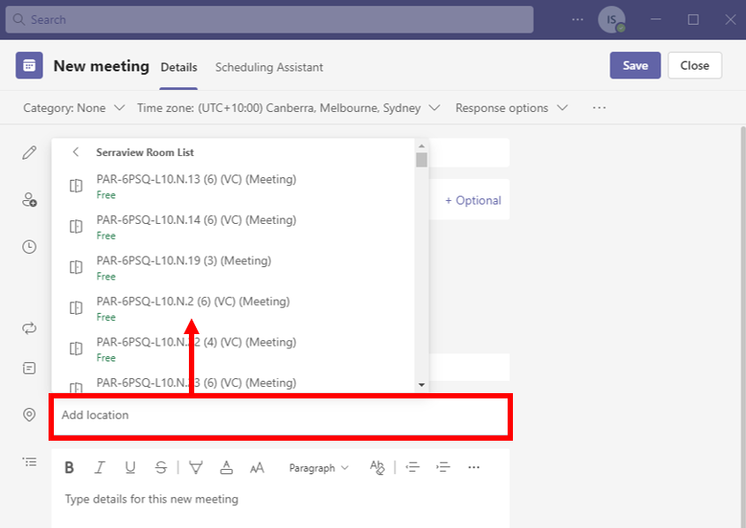
3 | Once you have sent the invitation you will receive an email notification confirming the room has been booked.

3. Forward a Microsoft Teams meeting to a meeting room
1 | If you receive a Microsoft Teams Meeting invite, you can forward this to a meeting room or multiple meeting rooms.  From the invitation select the More options icon and then Forward from the drop-down list.  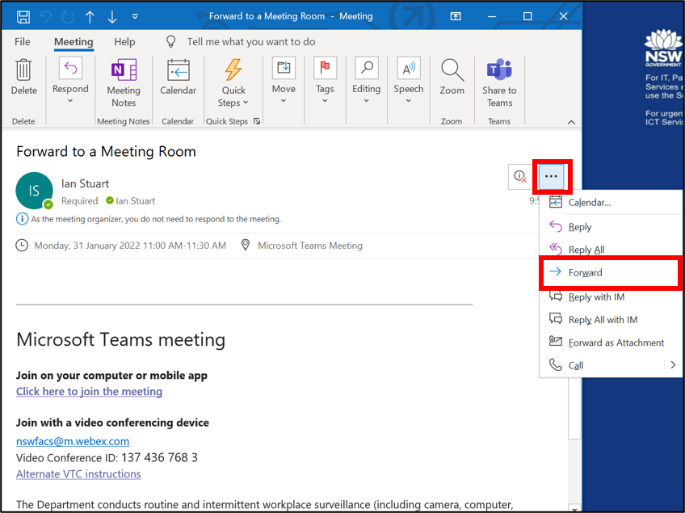
2 | Select the To … button to open the search window.  Start typing the suburb, building code and level refine the room list. You can invite multiple rooms from the same invitation as required.  Note the format of Suburb code + Hyphen + Building code + Hyphen + “L” + Level number for example, PAR-6PSQ-L04, will show you all meeting rooms on level 4 at 6 Parramatta square in Parramatta:  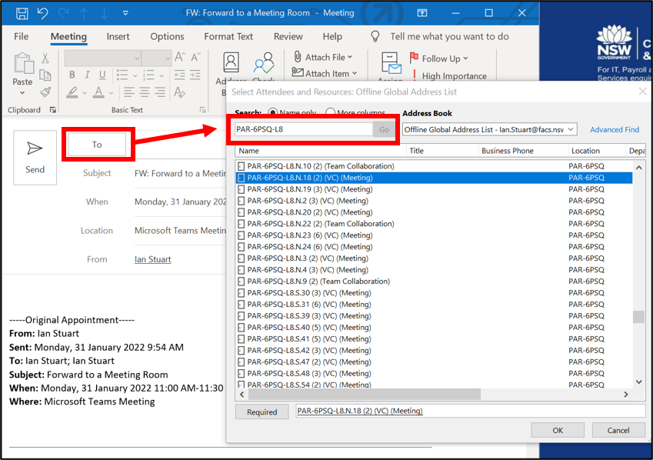
3 | Select the room or rooms, select the Required button and then OK.  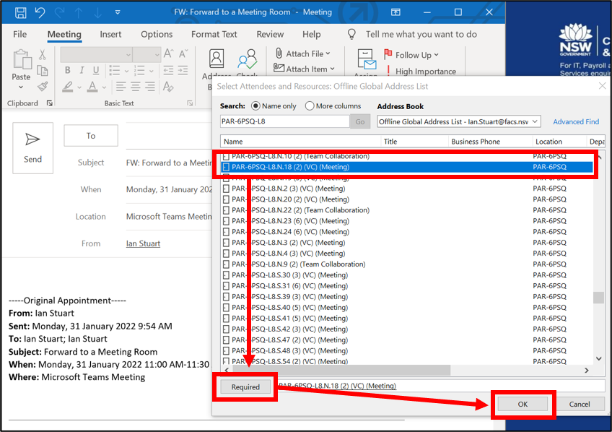  Note: Ensure that the room or rooms you are booking are available as the host will receive the accepted or denied notification for the room booking.

4. Join a scheduled meeting at the room
1 | On the console panel in the meeting room, find your meeting and select Join.  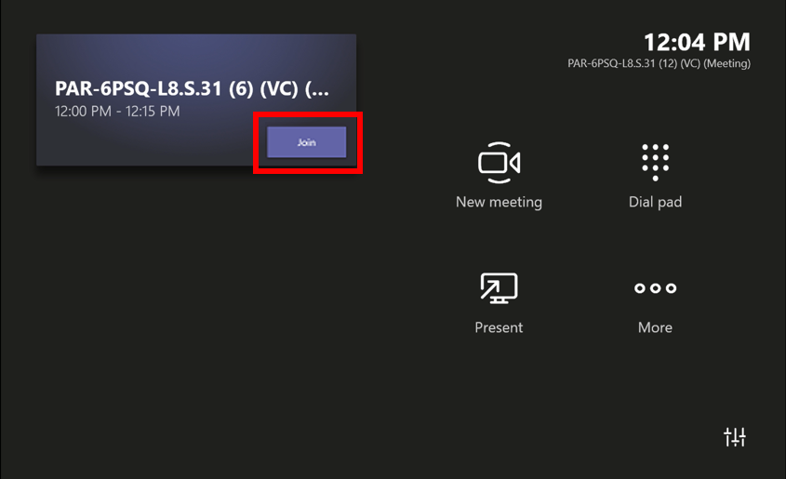  Note: there is no need also join via your laptop to use the room functionality.
2 | Your meeting will have similar controls to the Microsoft Teams app interface on your laptop.  To present, connect your laptop to the HDMI cable. This will always display your whole screen.  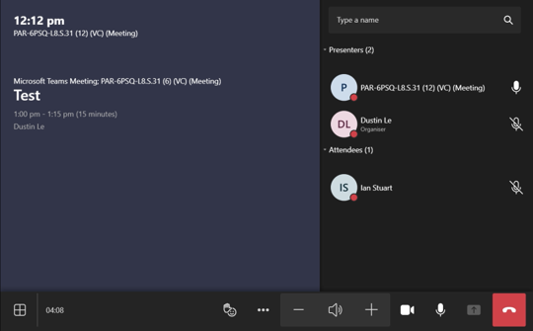  Note: you can also join the meeting on your laptop to present. If joining the meeting to share content it is important to select the Don’t use audio option before joining the meeting as this will prevent audio feedback in the meeting room.  Note: refer to the Meeting room technology overview user guide for help with using the console features.

